Institute of Management Sciences Peshawar
Result Analysis Report
Name: Haroon Bacha
Subject: Deep Learning
Semester and Program: BSDS (B)
Submitted to: Dr. Afsheen Khalid

Theoretical and Result Analysis Report: Gradient Descent Variants and Vanishing Gradient Problem
1. Introduction
This assignment aims to practically and theoretically analyze the behavior of three variants of Gradient Descent using a real-world dataset. Additionally, the vanishing gradient problem is demonstrated using a deep neural network. All experiments were implemented in Python using TensorFlow/Keras and executed on Google Colab. Loss graphs were generated to analyze convergence behavior.
2. Dataset Description
A small publicly available tabular dataset for binary classification was used. The dataset contains multiple numerical input features and one binary output label. Prior to training, feature scaling was applied using standard normalization to improve convergence speed and training stability.
3. Experimental Setup
A simple feedforward neural network was used for all gradient descent experiments to ensure fair comparison. The same architecture, learning rate, loss function, and number of epochs were kept constant, while only the batch size was varied to demonstrate different gradient descent variants.
Loss Function: Binary Cross-Entropy
Optimizer: Stochastic Gradient Descent (SGD)
Evaluation Metric: Training Loss
4. Batch Gradient Descent – Results
In Batch Gradient Descent, the model parameters were updated using the entire dataset in each iteration.
Observed Results:
- The loss curve decreases smoothly over epochs.
- There are minimal fluctuations in the loss graph.
- Convergence is stable but relatively slow.
Graph Interpretation:
The loss vs epoch graph shows a smooth and consistent downward trend, indicating stable learning. However, because updates occur after processing the entire dataset, training time per epoch is higher.
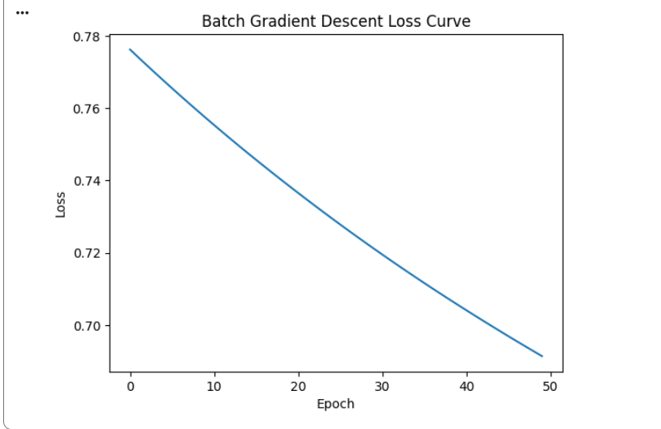
5. Stochastic Gradient Descent (SGD) – Results
In Stochastic Gradient Descent, parameters are updated after processing each individual training sample.
Observed Results:
- The loss curve shows significant fluctuations.
- Faster initial convergence compared to Batch GD.
- The loss does not decrease smoothly.
Graph Interpretation:
The loss graph appears noisy due to frequent updates using single samples. Although the model learns faster initially, instability is visible throughout training.
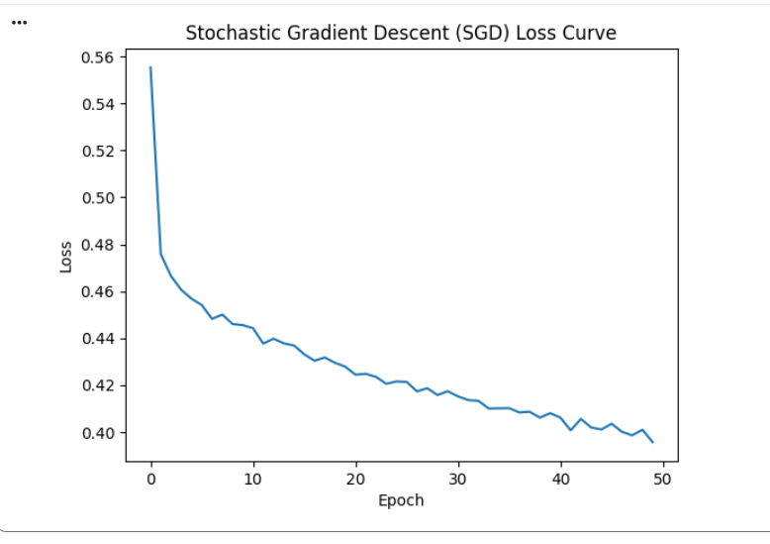
6. Mini-Batch Gradient Descent – Results
Mini-batch Gradient Descent updates parameters after processing small batches of data.
Observed Results:
- The loss curve is smoother than SGD.
- Faster convergence compared to Batch GD.
- Balanced stability and speed.
Graph Interpretation:
The loss curve shows a steady downward trend with minor oscillations. This confirms why mini-batch gradient descent is the most commonly used optimization method in deep learning.
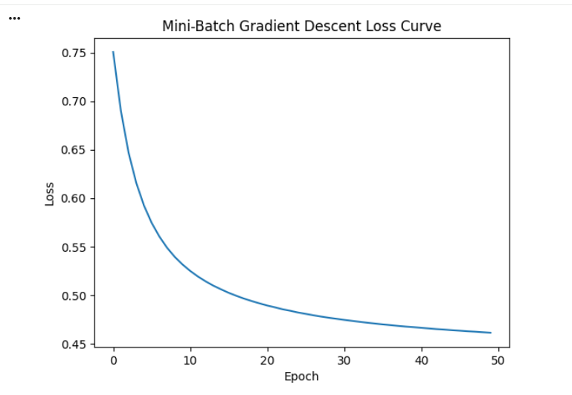

7. Comparative Analysis of Results
Comparison of the three approaches based on experimental results:
Batch Gradient Descent:
- Smooth loss curve
- Stable convergence
- Slow training
Stochastic Gradient Descent:
- Highly noisy loss curve
- Fast but unstable learning
Mini-Batch Gradient Descent:
- Balanced performance
- Faster and more stable convergence
- Best overall performance
The comparative loss graph clearly highlights these differences.
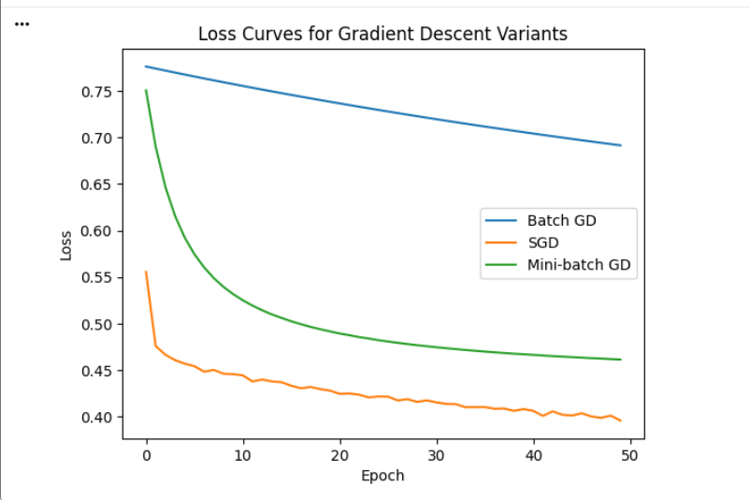
8. Vanishing Gradient Problem – Experimental Results
To demonstrate the vanishing gradient problem, a deep neural network with multiple hidden layers and sigmoid activation functions was trained on the same dataset.
Observed Results:
- Loss decreases very slowly after initial epochs.
- Training stagnates early.
- Model fails to learn meaningful patterns.
Graph Interpretation:
The loss vs epoch graph remains almost flat after a few epochs, indicating that weight updates are extremely small. This behavior confirms the presence of vanishing gradients.
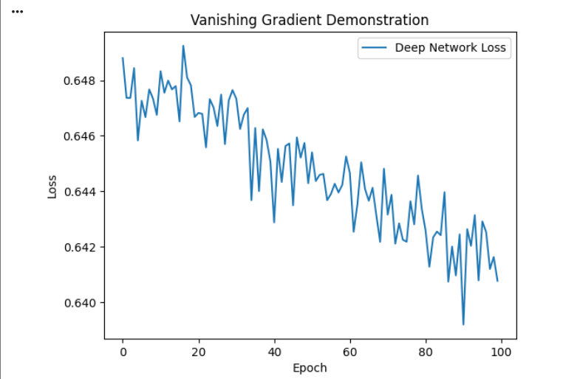
9. Explanation of Vanishing Gradient Behavior
The sigmoid activation function compresses values between 0 and 1. During backpropagation in deep networks, gradients become progressively smaller as they move toward earlier layers. As a result, early layers receive negligible updates, preventing effective learning.
Gradient norm analysis further confirms this issue, as extremely small gradient values were observed during training.
10. Conclusion
Based on the experimental results and loss curve analysis, it is concluded that:
- Mini-Batch Gradient Descent provides the best balance between speed and stability.
- Batch Gradient Descent is stable but computationally inefficient.
- Stochastic Gradient Descent is fast but unstable.
- Deep networks with sigmoid activation suffer from vanishing gradient problems.
This assignment successfully demonstrates both optimization behavior and fundamental challenges in deep learning training.

